

Functional Requirements Document (FRD)
  - Revelle Aesthetics – J938778

Copyright© 2018, Oracle and/or its affiliates. All rights reserved.
Any reproduction or distribution of any part of this document without the prior written permission of Oracle + NetSuite is strictly prohibited.
The information included in this document is confidential and proprietary information of Oracle + NetSuite.
Version: March 3, 2022

Oracle + NetSuite
2955 Campus Drive, Suite 100
San Mateo, CA. 99403-2511

Project Information
Implementation Name | Revelle Aesthetics Tax Form Page
Customer Name (Number) | Revelle Aesthetics
Job Name (Number) | J938778
Document Owner | Brady Onkka
Project Manager | Brady Onkka
Lead Developer | Ilan

Document Version History
Rev | Date | Author(s) | Change Summary
1.0 | 10/19/2023 | Brady | Initial Draft

Table of Contents
1 Business needs 4
2 Impacted areas/modules [Optional as output] 4
3 Acceptance criteria 4
4 Solution proposal 4
5 Prerequisites 5
6 Assumptions 6
7 Constraints and limitations 6
8 Risks 7

Business needs
Revelle Aesthetics is looking for a solution to allow shoppers to upload a PDF or Doc file into their customer record. This file will generally contain their tax exempt information, but if required Revelle customer service may use this page to have customers load other documents such as sale agreements when needed.

Impacted areas/modules [Optional as output]
This solution will require a creating a new custom page within My Account. This page will include an instruction text block, a space to load a file, and a button to submit the file.

Acceptance criteria
My Documents page will appear between Profile and Email sections under Settings. It will appear below the Additional Information page when its loaded.
Customers are able to load a Doc or PDF file via this page and it will show up within the Customer Record under Communication:
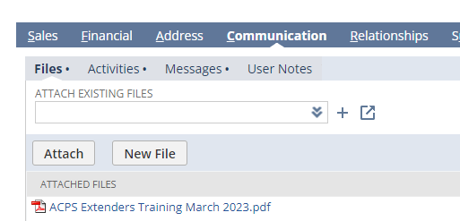

Solution proposal
Create a new page within My Account which will allow a customer to load a file into NetSuite.
- Create a new page within My Account in accordance with our existing solution.
  - This page will be called My Document.
  - This page will be located between Profile Information and Email Preferences.
    - 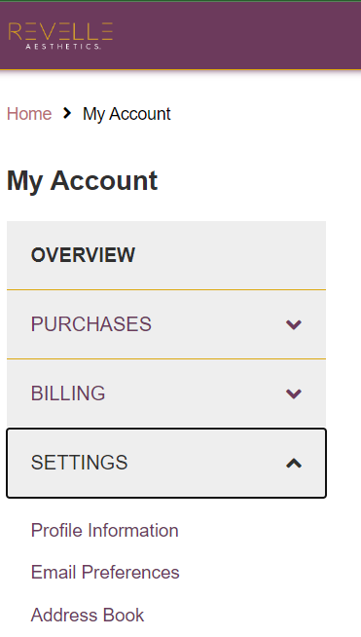
      - If Additional Information page is visible it is assumed it will appear after it.
  - When viewing this page, above the field were customers can insert the file to be downloaded a block of text will be included. Revelle will use this field to call out instructions for the customer.
  - This field should give the customer the ability to update the information displayed via translations. This means each field will have a unique label/value. All updates to these fields will be managed within Configuration Record > Mult-Domain > Translations. For reference:
    - 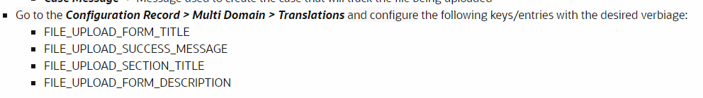
- Revelle wants the file deposited into the customer record, under files as shown in the screenshot below:
  - 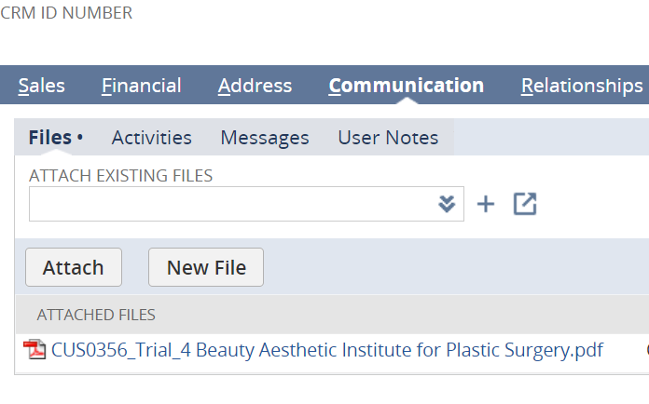

Prerequisites
GUIDELINE FOR THIS SECTION (DELETE TEXT BELOW ONCE THIS SECTION IS COMPLETED)
This section should list any prerequisite needed by the solution.
[This section is optional as final output on the document. The contents of this section will depend on if a prerequisite exists or not. Although the section is optional it must be part of the analysis process to determine if it is needed or not.]
For example:
- The Payment Instruments feature must be enabled.
- The payment gateway has been configured.
- Etc.
(DELETE TEXT ABOVE ONCE THIS SECTION IS COMPLETED)

Assumptions
- Revelle will be responsible for creating and maintaining their own alerts notifying them when files are uploaded
- Revelle is aware and accepting that they will be responsible for managing and removing files as needed to prevent them running out of space in the file cabinet.

Constraints and limitations
- Anything not explicitly called out in this document is considered out of scope and would need another job.
- Use only available SuiteCommerce Extensibility component classes to customize the extensions.

Risks
- These changes could be broken by future updates. Additional work may be needed at that time to correct and fix this custom extension.
- If working with SCS and CSS rules are being used to achieve certain behavior then the theme could be updated in the future and the CSS rules might no longer work (although this is highly improbable the risk exists).

Oracle + NetSuite Professional Services and Customer are in agreement that the information documented above is accurate and representative of the customer’s business needs. This document will act as the basis for all subsequent implementation activities.
Document delivery date: MM/DD/YYYY

